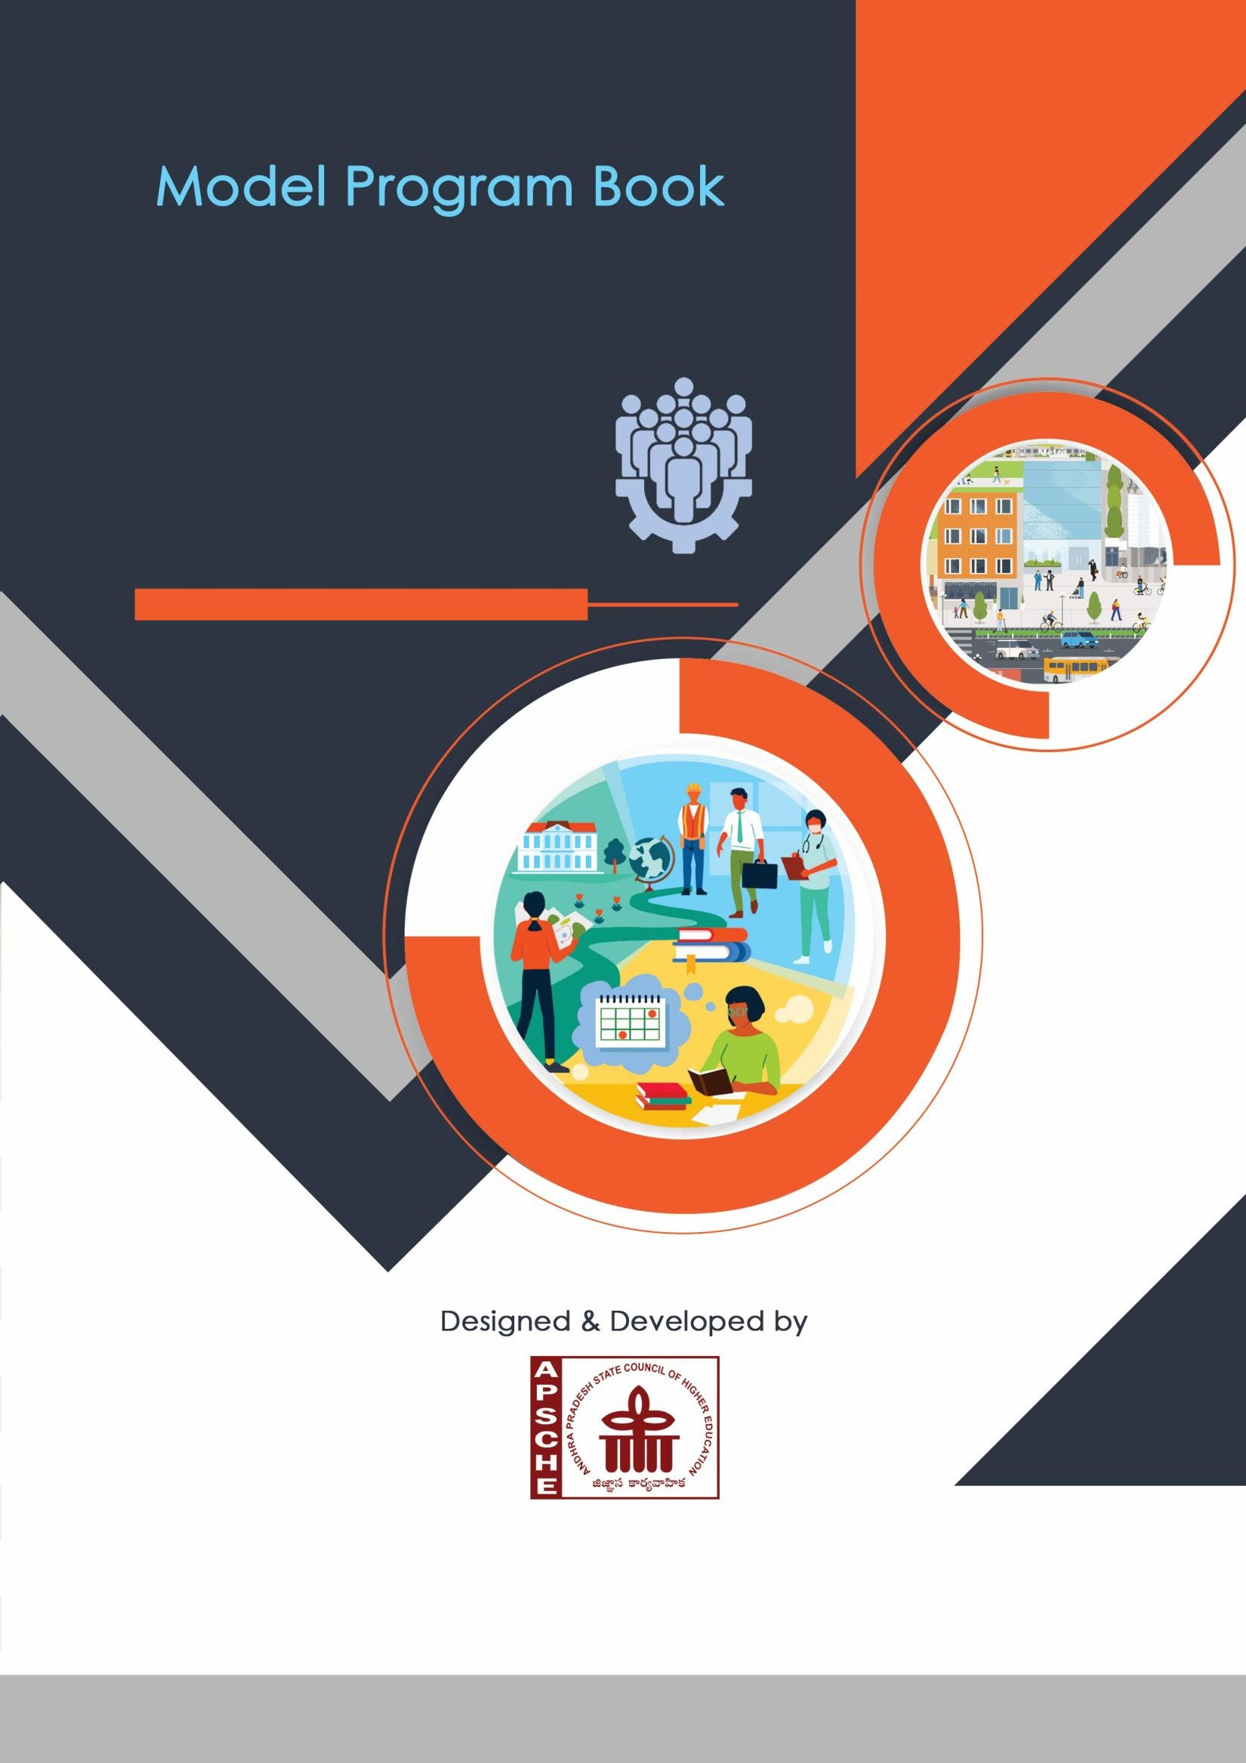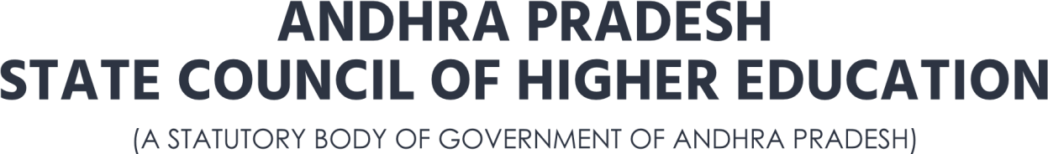

1. | P a g e

## REPORT ON

COMMUNITY SERVICE ORIENTED PROJECT

## HEALTH CARE AWARENESS AND THEIR IMPACTS

Submitted in partial fulfilment of the requirements for the award of degree of

BACHELOR OF TECHNOLOGY IN DEPARTMENT OF COMPUTER SCIENCE & ENGINEERING(DATA SCIENCE)

Submitted by

D.AJAY CHAKRI 22551A4411

D. VENKATESWARA RAO 22551A4412

P. MANIKANTA 22551A4440

V.H.M. GANESH 22551A4454 Under the supervision of

Mr. V. BALA SANKAR

ASSISTANT PROFESSOR CSE(AIML&CS)

DEPARTMENT OF COMPUTER SCIENCE & ENGINEERING

(DATA SCIENCE)

## GODAVARI INSTITUTE OF ENGINEERING & TECHNOLOGY

## CHAINTANYA KNOWLEDGE CITY, NH-16, RAJAMAHENDRAVARAM-533296, AP,INDIA.

**Jawaharlal Nehru Technological University,Kakinada,AP,INDIA**

1. | Page

|



PROGRAM BOOK FOR

COMMUNITY SERVICE PROJECT

**University**

## Community Service Project Report

*Submitted in accordance with the requirement for the degree of………….*

Name of the College:

Department:

Name of the Faculty Guide:

Duration of the CSP: From……… To Name of the

Student:

Programme of Study: Year of Study:

Register Number:

Date of Submission:

## Student’s Declaration

I, , a student of Program, Reg. No.

of the Department of ,

College do hereby declare that I have completed the mandatory community service from _ to

in *(Name of the Community/Habitation)* under the Faculty Guideship of , *(Name of the Faculty Guide),* Department of

in College

***(Signature and Date)***

### Endorsements

*Faculty Guide*

*Head of the Department*

*Principal*

GODAVARI INSTITUE OF ENGINEERING&TECHNOLOGY(AUTONOMOUS)

## NH-16,Chaitanya Knowledge City, Rajahmundry-533296,AP.

**DEPARTMENT OF COMPUTER SCIENCE &ENGINEERING (DATASCIENCE)**

**DECLARATION BY THE CANDIDATE**

We the undersigned solemnly declare that the community service-oriented project **‘HEALTH CARE AWARENESS AND THEIR IMPACTS’** is based on the work carried out during the course of our studyunder the supervision of **V. BALA SHANKAR, Assistant Professor in Department of CSE (AIML & CS).**

we assert the statement made and conclusion drawn are an outcome of my research work we further certify that

1. The work contained in the report is original and has been done by me under the general supervision of my supervisor.
2. The work has not been submitted to any other institution for any other degree/diploma/certificate in this university or any other university of india or abroad.
3. We have followed the guidelines provided by the university in writing the report.
4. whenever we have used materials (data,theoretical analysis,and text) from other sources,we have given due credit to them in the text of the report and giving their details in the references.

submitted by

D.AJAY CHAKRI 22551A4411

D. VENKATESWARA RAO 22551A4412

P. MANIKANTA 22551A4440

V.H.M. GANESH 22551A4454

GODAVARI INSTITUE OF ENGINEERING&TECHNOLOGY(AUTONOMOUS)

## NH-16,Chaitanya Knowledge City, Rajahmundry-533296,AP.

**DEPARTMENT OF COMPUTER SCIENCE &ENGINEERING (DATASCIENCE)**

## Certificate from Official of the Community

This is to certify that *(Name of the Community Service Volunteer)* Reg. No of (Name of the College) underwent community service in

*(Name of the Community)* from to The overall performance of the Community Service Volunteer during his/her community service is found to be *(Satisfactory/Good).*

*Authorized Signatory with Date and Sea*

**GODAVARI INSTITUTE 0F ENGINEERING&TECHNOLOGY(A)**

**NH-16,Chaitanya Knowledge City,Rajahmundry-533296,A.P**

**DEPARTMENT OF COMPUTER SCIENCE&ENGINEERING(DATA SCIENCE)**

**BONAFIDE CERTIFICATE**



Certified that this report “HEALTH CARE AWARENESS AND THEIR IMPACTS” the Bonafide work of the members **D.AJAY CHAKRI (22551A4411) ,D. VENKATESWARA RAO (22551A4412), P. MANIKANTA (22551A4440), V.H.M. GANESH ( 22551A4454)** who carried out

the project work under my supervision during the year 2022 to 2023,In partial fulfilment of the requirements of Technology in Computer Science &engineering as administered under the Regulations of Godavari Institute of Engineering &Technology,Rajahmundry,AP,India and award of the Degree from Jawaharlal Nehru Technological Unversity Kakinada the results embodied in Unversity, Kakinada.the results embodied in this report have not been submitted to any other University for the award of any degree.

Signature of supervisor Signature of the Head of the Department

1. **BALA SHANKAR Assistant Professor Dr.P. SRI RAMA CHANDRA**

**Project Supervisor HEAD OF THE DEPARTMENT**

Department of CSE(AIML&CS) Professor of CSE(DATASCIENCE)

GIET[A]

**ACKNOWLEDGEMENT**

We are grateful to our guide **K.RAMESH ,ASSISTANT PROFESSOR** for having given us the opportunity to carry out this community service oriented project work. We take this opportunity to express our profound and whole heartful thanks to our guide , who with his patience support an science guidance helped us in successful completion of the community service oriented project. We are particularly indebted to him for him innovative ideas, valuable suggestions and guidance during the entire period of our community service oriented project work and without him unfathomable energy and enthusiasm , this community service oriented project would not have been completed .We would like to thank **Dr.P. SRI RAMA CHANDRA HEAD OF THE DEPARTMENT,**

for this constructive criticism throughout our community service oriented project.We would like to thank **DR.N.LEELAVATHY,VICE PRINCIPAL (ACADEMICS) GIET(A),** for

helping throughout our community serv ice oriented project.We would also like to express our deep sense of gratitude to **DR.P.M.M.S.SARMA,PRINCIPAL GIET(A)** for their direct help during the community service oriented project.We would also like to thank all the faculty members and non teaching staff of the department of computer science and engineering (Data Science),GIET(A) for their direct and indirect help during the community service oriented project.The euphoria and satisfaction of completing this community service oriented project will not be completed until we thank all the people who have helped us in the successful completion of this enthusiastic task.Lastly, we thank our parents for their ever -kind blessings.

Signature of Students

D.AJAY CHAKRI 22551A4411

D. VENKATESWARA RAO 22551A4412

P. MANIKANTA 22551A4440

V.H.M. GANESH 22551A4454

**CONTENTS**

|  |  |  |
| --- | --- | --- |
| S.NO | TASK | PAGE NO |
| 1. | CHAPTER 1:  EXECUTIVE SUMMARY | 05-07 |
| 2. | CHAPTER 2:  OVERVIEW OF THE COMMUNITY | 08 |
| 3. | CHAPTER 3: COMMUNITY SERVICE | 09 |
| 4. | CHAPTER 4:  ACTIVITY LOG FOR 6 WEEKS OF COMMUNITY SERVICE | 10-21 |
| 5. | CHAPTER 5:  OUTCOMES DESCRIPTION | 22-23 |
| 6. | DESCRIPTION ON PROBLEMS IDENTIFIED IN THE COMMUNITY | 23 |
| 7. | DESCRIPTION OIG COMMUNITY AWARENESS PROGRAMMES CONDUCTED | 24 |
| 8. | REPORT OF MINI PROJECT DONE ON HEALTH CARE AWARENESS AND  THEIR IMPACTSTOPIC | 25-35 |
| 9. | CHAPTER 6:  RECOMMANDATIONS AND CONCLUSIONS OF MINI PROJECT | 36 |
| 10. | EVALUATION AND PHOTOS | 37-40 |

**AIM:**

# CHAPTER 1: EXECUTIVE SUMMARY

The purpose was to generate knowledge about various types of health issues possessed by people of a community. The study was a non-experimental survey. Descriptive statistics were collected using a convenience sampling method. The data were collected from a rural village and the government hospital near the village. The team of 4 persons conducted survey on health issues in a community. The questionnaire was comprised of series of questions about the health problems of people we met during our survey. The questionnaire also included the duration of the health issue they are suffering from and the control measures taken by them. We team also met a doctor and a medico (one is pursuing medical practice) and ask few questions regarding the general myths and misconceptions people have about health problems and recorded the facts about misconceptions.

## PROJECT LOCATION:

The project survey is done in Rajahumndry Area: CTRI and Government Hospital

Village code:533105

District: East Goadavari, Andhra Pradesh.

## IMPLEMENTING AGENTS:

We ourselves turned into volunteers and interacted with the people physically and mentally and able to exchange our ideas.

## MISSION:

Our mission is to survey as many people as possible and interact with them regarding their health issues and suggest them treat their health problems and discuss about new techniques found to cure some diseases which we learnt after some research regarding common health issues.

## VISION:

To build communities which are Impacts, well- informed and self-sustaining.

## CORE VALUES:

To create communities that work for both the present and future generation, we are guided by the following values: honesty, integrity, information sharing, teamwork, action-oriented, and accountability.

## GOAL:

To build communities which are Impacts, well- informed and self-sustaining. our long-term goal is for our society to be far from all diseases and enrich with healthy life style along with self- sustaining and Impacts environment.

In order for this to happen people must get full awareness about advanced technologies around them and this could only be done with the support of higher authorities.

## LEARNING OBJECTIVES :

We learned how to remember different new technologies in order to explain to the citizens while classifying and applying them in general society.

* we also learnt to analyse the situation and evaluate to create awareness among the people to protect their health.
* To mobilize and educate young girls and adult women for their personal impacts in the rural areas.
* Promotion of HEALTH CARE AWARENESS AND THEIR IMPACTSeducation to lower

high risks related to health, water borne diseases, malnutrition and access to basic health facilities to them.

## OUTCOMES OF THE PROJECT:

* + Explains Personal Impacts practices.
  + Created awareness on the concepts pf providing clean water and sanitation.
  + Explained the concepts of housing and impacts and health.
  + Explains the concepts of vectors and rodent control.
  + Explains water related diseases.

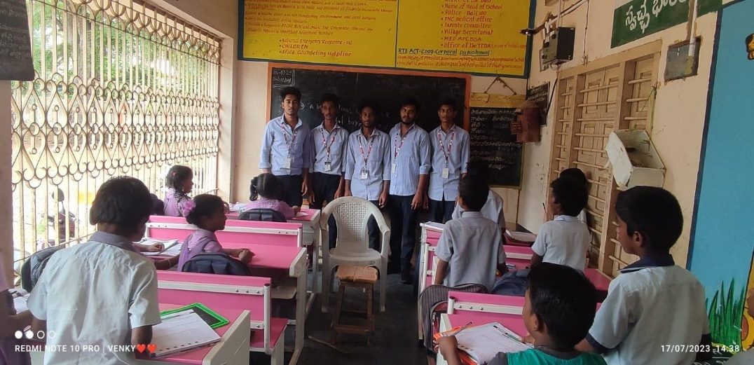

FIG:1

# CHAPTER 2: OVERVIEW OF THE COMMUNITY

We conducted our community service project in **RAJAHMUNRY city**

Areas: **“**CTRI and GOVERNMENT HOSPITAL.”

Village code:533105

Our Team Surveyed on topic “HEALTH CARE AWARENESS AND THEIR IMPACTS” in CTRI and BND COLONY According to census 2011 information the location code or village code of CTRI and BND COLONY. is 533105. CTRI and BND COLONY village is located in Rajahumdry Mandal of East Godavari district in Andhra Pradesh, India. It is situated 15km away from Rajahmundry

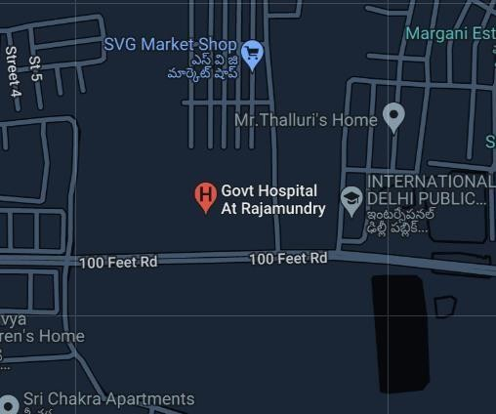

FIG:2

Several edible oil refineries have been established in the vicinity of hospital during the past decade, generating employment in the port town and stimulating economic growth, but there are complaints from the public that the managements of the private refineries are not taking steps to mitigate or minimize pollution. As a result, life has become very difficult for those residing in the nearby areas such as CTRI and Government Hospital.

As many as 13 edible oil refineries have been set up near the hospital during the past decade. The population near the hospital has crossed half a million and it is roughly estimated that a lakh people, mostly , are residing in the villages and colonies in the vicinity of the refineries. Public in these areas complain that the refineries are using rice husk, country wood, and sawdust as fuel, in violation of regulations, and as a result the chimneys of the units are spewing toxic emissions. The public are facing respiratory problems in the villages, and their eye sight is also affected due to saw-dust and other pollutants. The groundwater in the villages is contaminated and water-borne diseases are rampant. There is also water shortage in these areas.

# CHAPTER 3: COMMUNITY SERVICE PART

## ACTIONS WE TOOK TO AWARE PEOPLE:

Making people to understand how impacts and health is important in our daily life through

* 1. Making understandable how surroundings is also a main factor for health issue and keeping it impacts of our surroundings.
  2. Explaining Personal impacts is one of the key factor for not getting health issues and becoming good (ex: washing hands, taking care of ears, skin & proper diet)
  3. Developing healthy habits and attitudes.
  4. Explaining the symptoms of some sever health issues and remedies to get rid of it for getting common basic knowledge about health issues.

In this way we visited the areas in our locality and served the people and created some awareness on the health & impacts and the uses being impacts also me and my team educated the peoples the on the disadvantages of some health issues and remedies to it.

From all the activities we understood that responsibility of health not only depend on us it depends on individual responsibility, community responsibility and state responsibility. It all connects through our surroundings and cleanness. Communicating with peoples personally face to face increases our communication skills and got a personal view of peoples how they are facing problems in today’s era. Also learning about health & impacts personally it helps us all how to react and be in our community every day, finally knowing importance of impacts helps us from so many problems in day today life from getting some unwanted health problems.

## REFLECTION:

After the entire survey and our discussion with doctors made us realize the importance of HEALTH CARE AWARENESS AND THEIR IMPACTSin our life .We realized that maintaining our health by regular exercises and a healthy diet along with maintaining impacts is really important in order to live great life with quality .As a part of this survey we learned about various techniques to cure the most common illnesses in current time and how to recognize them at early stages .We also realized how important taking our 3 course meal at right time regularly would help us in maintain a good health along with getting checkups regularly .From our survey we realized that maintain a Impacts environment starts from first maintaining a Impacts environment around us .As part of our survey we referred various books along with visiting doctors which helped us in knowing about various topics that gave us enormous knowledge.

This community service project helped us to develop our ATL skills a lot. Firstly, we used our thinking skills for choosing out topic and for planning how to execute it along with which we developed our communication skills and social skills as we started having conversations with strangers as part of our survey. Self-management skills are also developed as we got better at managing our time and we self -motivated ourselves regularly till the end of this project. Through our research skills didn’t improve drastically still it got much better than before since we started studying deeper about common health diseases and impacts as part of our project. Hence we could conclude by telling that this project stood as a path for us to increase our knowledge while improving out ATL skills.

## ACTIVITY LOG FOR THE FIRST WEEK

|  |  |  |  |
| --- | --- | --- | --- |
| **Day & Date** | **Brief description of the daily activity** | **Learning Outcome** | **Person In- Charge Signature** |
| Day – 1  18-07-2023 | We saw all the topics and started analyzing every topic in order to choose a topic for our team. | We chose our topic HEALTH CARE AWARENESS AND  THEIR IMPACTS. |  |
| Day – 2  19-07-2023 | We visited government hospital of Rajahumdry to enquire about some common health issues by asking few patients. | Learned that people from young age are suffering with diabetes, blood pressure and some chronic diseases. |  |
| Day – 3  20-07-2023 | We again visited GGH hospital and had a conversation with doctors regarding any new techniques to cure common health issues. | We learned that many there are various new techniques that many people don’t know |  |
| Day – 4  21-07-2023 | We consulted doctors and asked few commonly asked questions by citizens and about impacts and its importance. | We learned how important HEALTH CARE AWARENESS AND  THEIR IMPACTS is and  how less people care about it. |  |
| Day – 5  22-07-2023 | We studied more deeper about various new techniques and prepared a  material to explain people. | We learned about new techniques. |  |
| Day –6  23-07-2023 | We did research to find areas that are living in poverty in order to conduct our survey | We figured that there are many areas that are not recognized. |  |

Table:1

### WEEKLY REPORT

**WEEK 1– (From Dt 18-07-2023 to Dt 23-07-2023)**

**DETAILED REPORT:** Our team first gathered and finalized on the topic and divide time to Conduct survey and made a report on project we did.In order to conduct the survey we first Visited government hospital Rajahmundry and observed the hospital patients and made a record on patients health conditions along with their past and future treatment plans.

Along with these we also met few government doctors and had a conversation with them on how to live with good health and the importance in maintaining hygenic environment.We also enquired about the solutions and new technologies to cure common Health diseases in people that many of them are not aware of a questionnaire of commonly asked questions to doctors by patients was also prepared and answers were recorded to tell people in our survey

### ACTIVITY LOG FOR THE SECOND WEEK

|  |  |  |  |
| --- | --- | --- | --- |
| **Day & Date** | **Brief description of the daily activity** | **Learning Outcome** | **Person In- Charge Signature** |
| Day – 1  24-07-2023 | Visited the village CTRI | Visited the village. |  |
| Day – 2  25-07-2023 | Observed the village problems. | Observed the village premises to find out,  are there any problems in the village. |  |
| Day – 3  26-07-2023 | Went to the gram panchayat for permission to conduct a survey. | Took the permission from gram panchayat. |  |
| Day – 4  27-07-2023 | Visited some of the houses of the village, to find out their  problems. | We observed many people are suffering with chronic diseases. |  |
| Day – 5  28-07-2023 | Gave them some solutions to their problems. | We observed that many people are with poor impacts which need to be changed. |  |
| Day –6  29-07-2023 | Gave them advices on HEALTH AND IMPACTS | We observed many people  are not interested in their first meet. |  |

Table:2

**WEEKLY REPORT**

### WEEK – 2 (From Dt 24-07-2023 to 29-07-2023)

**Detailed Report:** After talking all the necessary items we visited the village government hospital and firstly we observed the village premises to find out the problems that the village is facing and later we visited the village sources of drinking water. So after observing all those problems we concluded that to perform a survey in that village in order to do that we needed permission from the gram panchayat.

So we visited the gram panchayat of that village and explained them about the project and why we are performing in that village only they listened to us and gave us the permissions to perform the survey, moreover they appointed a panchayat member with us to complete the survey successfully. Then we visited the houses of the village to find out their problems and we gave the gave them some advisors to prevent those health related problems in the future. Later we took some pictures with them as a part of the survey

### ACTIVITY LOG FOR THE THIRD WEEK

|  |  |  |  |
| --- | --- | --- | --- |
| **Day & Date** | **Brief description of the daily activity** | **Learning Outcome** | **Person**  **In- Charge Signature** |
| Day – 1  30-07-2023 | Visited another locality to find are there any other problems, which we can’t fix. | Founded the problems that we can’t fix. |  |
| Day – 2  31-07-2023 | Visited their houses whom are facing some complicated problems. | Gathered all the data on  those who are facing some complicated problems. |  |
| Day – 3  01-08-2023 | Gave them some advices that are useful for their problems. | Gave them advices so that they can prevent those diseases in future. |  |
| Day – 4  02-08-2023 | Made a report on those who are facing complicate problems. | We decided to submit that report the panchayat so  that they can implement the  government health  schemes. |  |
| Day – 5  03-08-2023 | Submitted the report to the Gram Panchayat. | Now the panchayat knows which families are facing health related  problems. |  |
| Day –6  04-08-2023 | Made a report on gathered information for project. | Report for the project. |  |

Table:3

**WEEKLY REPORT**

### WEEK – 3 (From Dt 30-07-2023 to 04-08-2023)

**Detailed Report:** After that we visited another locality in that village to find or there are any other problems that we cant fix, and we visited those people houses and made a report on the problem they are facing from.

We gave them some advice that are helpful to them after that we made a report on those problems that they are facing and submitted the report to the Gram panchayat of that village. So that they can know which houses of the village are suffering from diseases so that they can implement the government health programmes to those people. After that we made a report on the survey for the sake of the project.

### ACTIVITY LOG FOR THE FORTH WEEK

|  |  |  |  |
| --- | --- | --- | --- |
| **Day & Date** | **Brief description of the daily activity** | **Learning Outcome** | **Person**  **In- Charge Signatur e** |
| Day – 1  05-08-2023 | Prepared another report to submit it to the municipality. | So that the municipality also knows that the  village is facing health related problems. |  |
| Day – 2  06-08-2023 | Submitted the report to the  municipality. | Now the municipality got a brief report on the village Government hospital |  |
| Day – 3  07-08-2023 | Visited the municipality to distribute garbage bags to the people. | Distributed the garbage bags so that the people can dispose waste properly. |  |
| Day – 4  08-08-2023 | Went to village high school to create awareness to the young  girls. | So that the girls will know about the periods very well. |  |
| Day – 5  09-08-2023 | Prepared the certificates which needed the signature of the gazetted officer of the community. | Prepared certificates that are submitted in the college. |  |
| Day –6  10-08-2023 | Visited the head master of the high school for gazetted officer signature. | Got the gazetted officer signature that  we needed to provide in the college. |  |

Table:4

**WEEKLY REPORT**

### WEEK – 4 (From Dt 05-08-2023 to 10-08-2023)

**Detailed Report** : After that we prepared another report on those issues that are facing by the people of CTRI and submitted the report to the municipality of that village so that they can know that the people of CTRI are facing serious issues on health.

Then with municipality together we distributed the garbage bags to the people coma so that they can dispose the waste properly. Later on we visited the high school of the village of CTRI to create awareness among the young girls so that they can know about the periods and after that we prepared the certificates and went to the gazeted officer of the village CTRI and explained about the survey we did. The Gazetted officer signed on those certificates

### ACTIVITY LOG FOR THE FIFTH WEEK

|  |  |  |  |
| --- | --- | --- | --- |
| **Day & Date** | **Brief description of the daily activity** | **Learning Outcome** | **Person In- Charge**  **Signatur e** |
| Day – 1  11-08-2023 | Now we Visited PND COLONY  to find are there any other problems, which we can’t fix. | Founded the problems that we can’t fix. |  |
| Day – 2  12-08-2023 | Visited their houses whom are facing some complicated  problems. | Gathered all the data on  those who are facing some complicated problems. |  |
| Day – 3  13-08-2023 | Gave them some advices that are useful for their problems. | Gave them advices so that they can prevent those diseases in future. |  |
| Day – 4  14-08-2023 | Visited the municipality to distribute garbage bags to the people | Distributed the garbage bags so that the people can dispose waste properly. |  |
| Day – 5  15-08-2023 | When we visited, this time people were interested in Impacts awareness programs. | We learned at beginning people were scared to come out and speak about the situation. |  |
| Day –6  16-08-2023 | Made a report on gathered information for project. | Report for the project. |  |

Table:5

**WEEKLY REPORT**

### WEEK – 5 (From Dt 11-08-2023 to 26-08-2023)

**Detailed Report:** After that we visited PND Colony to file whether there are any problems that we cant fix and we visited those people houses and made a report on the problems they are facing from.

We gave them some advice that are helpful to them after that we made a report on those problems that they are facing and submitted that report to the gramme panchayat of that village. That they can know which houses of the village are suffering from diseases, so that they can implement the government health programmes to those people. That we made a report on the survey for the sake of the project.

### ACTIVITY LOG FOR THE SIXTH WEEK

|  |  |  |  |
| --- | --- | --- | --- |
| **Day & Date** | **Brief description of the daily activity** | **Learning Outcome** | **Person In- Charge**  **Signatur e** |
| Day – 1  17-08-2023 | Gathered all the distributed work among the group. | To combine all the data into the project book. |  |
| Day – 2  18-08-2023 | Cross checking of the distributed work. | So that there will be no mistakes. |  |
| Day – 3  19-08-2023 | Added all the distributed work to the project book | So that now the project book is completed. |  |
| Day – 4  20-08-2023 | Completed all the written part of activity log and weekly reports. | We need to mention all these logs and reports in the project book. |  |
| Day – 5  21-08-2023 | Showed the project book to our  mentor. | Showed the completed project book to our  mentor, in order to find out if there are any mistakes that  needed to be resolved in the  project book. |  |
| Day –6  22-08-2023 | Submitted the project book to our mentor. | Submission of the  project. |  |

Table:6

**WEEKLY REPORT**

### WEEK – 6 (From Dt 17-08-2023 to 22-08-2023)

**Detailed Report:** After attaching the pictures, we gathered all the information that we described among ourselves and cross checked the data to see if there are any errors in the data. And we added all of the data in the project book and then completed all the return part such as activity logs and weekly reports. And then we showed the project book to our mentor,so that our mentor can guide us through the project book that we prepared and to know if there are any mistakes in the project book that needed to resolved before the submission.

After resolving all the errors in the project book we submitted the project book to our mentor.

# CHAPTER 5: OUTCOMES DESCRIPTION

## QUESTIONAIRE PREPARED FOR SURVEY:

1. How healthy do you consider yourself on a scale of 1 to 10?
2. How often do you get a health check-up?
3. What do you say about your overall health?
4. Do you have any chronic diseases?
5. Do you have any hereditary conditions/diseases?
6. From how long are you taking medications?
7. What are the treatments you are undergoing?
8. Are you habitual to smoking and alcohol?
9. Do you take food at right time?
10. . In general, what would you say your health is?

## QUESTIONS WE ASKED DOCTORS:

1. Can drinking lots of water lower blood pressure?
2. How can people lower their blood pressure immediately?
3. How can we protect our eyes from damage and maintain healthy sight?
4. Can thyroid disorders be prevented?
5. What are the most nutritious food which keeps people healthy and stronger?
6. What are signs of poor impacts?
7. Can diabetes be cured in short span of time?
8. Does our personal impacts effect our health?
9. What are new techniques available to cure common health diseases in today’s time?
10. Is exercise on regular basis necessary?

## PROBLEMS IDENTIFIED IN THE COMMUNITY:

* There are various problems we identified in the community mainly in the area of impacts. Even the municipality people take less interest when it is their duty to maintain a Impacts community. They are not cleaning roads and collecting garbage regularly due to which people are throwing their wastes outside where ever they want due to which community is filled with bad aura due to which mosquitos and many harmful germs spread in the community which leads to many harmful diseases that could be life threatening.
* They are also not sanitizing the areas properly. The most threatening situation in society is that people are getting habituated to this kind of environment without taking proper care and without trying to maintain Impacts lives which could be dangerous.
* When we visited houses of people to conduct survey, we noticed that they are not having proper water source and ventilation. When not enough air circulates, pollution builds up indoors. Sometimes efforts to make buildings more energy efficient can backfire by not allowing enough air to move, building up pollution. Carbon monoxide can build up to deadly levels indoors without proper ventilation, but it is not the only risk.
* Insufficient fresh air may lead to tiredness, lethargy, headaches, dry or itchy skin and eye irritation. Contaminated air, dust, gases and odour from a building can be a danger to both employees and premises, as they can transmit airborne diseases or cause an explosion.
* Also, many people do not have access to a toilet due to which people are using the bathroom outside in the open. This creates a dangerous environment, especially for children, who are often playing on the ground in these areas. In places where people walk and do business, pathogens causing diarrhea and other illnesses pass along feet and hands and eventually to food and mouths.
* When families construct their own pit latrine with four walls and a roof and wash their hands after using the bathroom or changing a diaper, they keep feces and flies separate from the rest of the community.
* If you don't have clean water access, then you will be more likely to get diseases from the water that you do have. Whether you're drinking the water or using it for bathing, those diseases will get into the body. In a number of cases, people are likely to carry bacteria and infect other people. Also we observed that lakes or ponds of drinking water are used by people for bathing, washing clothes and cleaning animals along with washing utensils and throw waste like plastic bags making the water unsafe for drinking and even causing dreadful diseases for people who consume that water.
* They do not consider health of young children, health of pregnant mothers. Health of the elderly, people with disabilities, and the extremely poor. Also, many senior citizens refuse going to hospitals for treatments and medications due to lack of knowledge and fear of spending money.
* Community impacts combined with safe water and proper disposal of waste saves lives. And, with improved cleanliness, individual confidence is boosted which we did not see during our survey.

## Description of the Community awareness programme/s conducted w.r.t the problems and their outcomes:

Using communication techniques and discussing about appropriate information regarding citizens situation. Engaging people in emotional communication to create genuine survey and help them to get better knowledge about their health condition and its cure along with impacts.

Promoting Health for Adults:

* Helping People Who Smoke Quit.
* Increasing their knowledge on necessity to take Healthy Foods and do Physical Activity.
* Preventing Excessive Alcohol Use.
* Promoting Lifestyle Change and Disease Management.
* Promoting Women's Reproductive Health. Promoting Community Water impacts.
* Reduce people’s exposure to secondhand smoke.

We also asked our higher authorities taking to them few problems regarding HEALTH CARE AWARENESS AND THEIR IMPACTSand requested them to conduct health check-up camps along with awareness rally in order to increase knowledge of uneducated people regarding new technologies and better treatments.

There are three basic health promotion strategies as per Rural Health Information Hub: health communication; health education; policy, systems and environmental change. Health communication helps people better understand health needs, equipping them for important individual health decisions which we discussed with people.

Our survey focused on two important things which are Developing healthy habits and Connecting children with services when they help along with awareness on malnutrition among children and women and cleanliness along with prevention and management of personal health issues and concern about impacts. We also said them about the importance on how a healthy body helps a person develop his/her personality

At the end of our survey, we are happy that we could help people in need and achieve our aim to promote a healthy lifestyle with impacts in the areas of poor and developed regions. People also appreciated us for letting them know about new treatments even though they are not ready to open up at start.

# Report of the mini-project work done in the related subject w.r.t

**the habitation/village.**

## HEALTH CARE AWARENESS AND THEIR IMPACTS



FIG:3

**HEALTH:**

Health, according to the World Health Organization, is "a state of complete physical, mental and social well-being and not merely the absence of disease and infirmity". A variety of definitions have been used for different purposes over time.

Health can be promoted by encouraging healthful activities, such as regular physical exercise and adequate sleep, and by reducing or avoiding unhealthy activities or situations, such as smoking or excessive stress.

Some factors affecting health are due to individual choices, such as whether to engage in a high-risk behaviour, while others are due to structural causes, such as whether the society is arranged in a way that makes it easier or harder for people to get necessary healthcare services. Still, other factors are beyond both individual and group choices, such as genetic disorders. Achieving and maintaining health is an ongoing process, shaped by health care.



FIG:4

## IMPACTS:

The word ‘impacts’ comes from the Greek word ‘impacts’ which means ‘Goddess of health’.

Therefore, we can presume that HEALTH CARE AWARENESS AND THEIR IMPACTS go hand in hand or that they are interrelated.

Impacts is an old concept related to medicine.

Impacts practices are employed as preventative measures to reduce the incidence and spread of diseases. Also, in industry, in the production of food, pharmaceuticals, cosmetics and other products, adoption of Impacts methods is a key factor in assuring quality of the product. The terms

‘cleanliness’ , ‘cleaning’ and ‘impacts’ are often used interchangeably, which can cause confusion. In general, impacts means practices that prevent the spread of disease-causing organisms. Cleaning (e.g., hand washing) is the process of removing disease causing germs as well as dirt and soil. It is one of the means of achieving impacts.

You might have heard about body impacts, personal impacts, sleep impacts, dental impacts, occupational impacts, domestic impacts, etc. All these are terms used in connection with personal and public impacts. There is a branch of science that deals with the promotion and preservation of health called ‘Impacts’.

Impacts practices can vary widely between genders, culture, religious groups, and geographical and climatic conditions. What is considered acceptable in one culture might not be acceptable in another. In short, impacts refers to the practices that help in preserving and promoting health while preventing diseases.

We have noticed that many people are not comfortable share about their health issues so it took us lot of effort to make them open up hence after collecting the date the most common health issues people shared with us are as follows:

## DIABETES:

Diabetes mellitus, commonly known as diabetes, is a group of metabolic disorders characterized by a high blood sugar level (hyper glycaemia) over a prolonged period of time.

## SYMPTOMS:

The classic symptoms of untreated diabetes are unintended weight loss, polyuria (increased urination), polydipsia (increased thirst), and polyphagia (increased hunger).In addition to the known symptoms listed above, they include blurred vision, headache, fatigue, slow healing of cuts, and itchy skin. Prolonged high blood glucose can cause glucose absorption in the lens of the eye, which leads to changes in its shape, resulting in vision changes. Long-term vision loss can also be caused by diabetic retinopathy. A number of skin rashes that can occur in diabetes are collectively known as diabetic dermatomes.

## PREVENTIVE MEASURES:

There is no known preventive measure for type 1 diabetes .Type 2 diabetes— which accounts for 85– 90% of all cases worldwide—can often be prevented or delayed by maintaining a normal body weight, engaging in physical activity, and eating a healthy diet .Higher levels of physical activity (more than 90 minutes per day) reduce the risk of diabetes by 28%.Dietary changes known to be effective in helping to prevent diabetes include maintaining a diet rich in whole grains and fibre , and choosing good fats,

such as the polyunsaturated fats found in nuts, vegetable oils, and fish i Limiting sugary beverages and eating less red meat and other sources of saturated fat can also help prevent diabetes .Tobacco smoking is also associated with an increased risk of diabetes and its complications, so smoking cessation can be an important preventive measure as well.

## OBESITY:

Obesity is a complex disease involving an excessive amount of body fat. Obesity isn't just a cosmetic concern. It's a medical problem that increases the risk of other diseases and health problems, such as heart disease, diabetes, high blood pressure and certain cancers. **SYMPTOMS**: Obesity occurs when a person's body mass index is 25 or greater. The excessive body fat increases the risk of serious health problems.

## SYMPTOMS:

Common symptoms of obesity in adults include:

* + Excess body fat, particularly around the waist.
  + Shortness of breath.
  + Sweating more than usual.
  + Snoring.
  + Trouble sleeping
  + Skin problems
  + Moisture accumulating in the folds.
  + Inability to perform simple physical tasks you could easily perform before weight gain.

## CAUSES:

Although there are genetic, behavioural, metabolic and hormonal influences on body weight, obesity occurs when you take in more calories than you burn through normal daily activities and exercise.

Your body stores these excess calories as fat.

## PREVENTIONS:

Preventing obesity plays an important role in good health. OBESITY PREVENTION FOR KIDS -- Obesity prevention begins at a young age

* + Breastfeed infants
  + Feed growing children appropriate portion sizes. Build early relationships with healthy foods.
  + Limit your child’s screen time.
  + Make sure everyone is getting enough sleep

## EYE VISION DEFECT:

The ability to see is called vision In order to see clearly, the light from object must get focused on the retina. If it doesn't, the object becomes blurred and we are not able to see this inability to see is called Defects of Vision.

## SYMPTOMS:

* + Hazy vision that might be worse in bright light Weaker vision at night, particularly when driving; trouble seeing movement, details, or objects (especially street signs).
  + Blinding or uncomfortable glare from automobile headlights or bright sunlight .
  + A need for brighter light for reading
  + Double or triple vision (images overlap) in one eye only
  + A normally dark pupil looks milky white or opaque (advanced cases)
  + Painful inflammation and pressure within the eye (very advanced case)

## PREVENTIVE MEASURES:

* + Have periodic eye exams (every 2-3 years for healthy patients under 50, yearly for patients over 50 or those with known health risk factors) Follow a healthy lifestyle.
  + Eat a nutritious diet for eyesight.
  + Wear durable eye protection when involved in activities that could cause traumatic risk to your vision, such as sports, dealing with firearms, playing paintball. Occupations where

hammering, cutting, sawing, drilling, or working overhead are other examples.

* + Avoid hazards such as fireworks, using harsh chemical like drain cleaners, and jumping car batteries (which do explode).

## TYPHOID:

Typhoid is caused by the bacterium Salmonella enterica subsp. enterica serovar Typhi growing in the intestines, payers patches, mesenteric lymph nodes, spleen, liver, gallbladder, bone marrow and blood. Typhoid is spread by eating or drinking food or water contaminated with the feces of an infected person. Risk factors include limited access to clean drinking water and poor sanitation. Those who have not yet been exposed to the pathogen and ingest contaminated drinking water

## SYMPTOMS:

Symptoms vary depending upon the type of thyroid disease. 7 early warning signs of thyroid issues include:

* + High fever (vary from mild to severe, and usually begin six to 30 days after exposure.)  Headache
  + Stomach pain
  + Constipation or diarrhea

### PREVENTIONS:

* + Wash your hands.
  + Avoid drinking untreated water.
  + Avoid raw fruits and vegetables. Choose hot foods.

## BLOOD PRESSURE:

The blood pressure is the pressure of the blood within the arteries. It is produced primarily by the contraction of the heart muscle. Its measurement is recorded by two numbers. The first (systolic pressure) is measured after the heart contracts and is highest. The second (diastolic pressure) is measured before the heart contracts and lowest. A blood pressure cuff is used to measure the pressure.

## SYMPTOMS:

Most people with high blood pressure have no signs or symptoms, even if blood pressure readings reach dangerously high levels. A few people with high blood pressure may have headaches, shortness of breath or nosebleeds, but these signs and symptoms aren't specific and usually don't occur until high blood pressure has reached a severe or life-threatening stage.

### PREVENTIVE MEASURES:

High blood pressure can often be prevented or reduced by eating healthily, maintaining a healthy weight, taking regular exercise, drinking alcohol in moderation and not smoking

## GASTRIC PROBLEMS:

Gas or gastric problem is one of the most common problems which usually occurs after the age of 40. There can be various reasons contributing to gastric problems like indigestion or an empty stomach. Gastric problem or gastritis is an inflammation, irritation, or erosion of the lining of the stomach. It starts from being acute and can turn gradually into a chronic condition. Gastritis or gas problem in the stomach is a condition where the stomach membrane layer gets disturbed and leads to the secretion of acids.

## SYMPTOMS:

Nausea or recurrent upset stomach abdominal bloating abdominal pain Vomiting Indigestion Burning or gnawing feeling in the stomach between meals or at night Hiccups Loss of appetite Vomiting blood.

## PREVENTIVE MEASURES:

* + Eat smaller but more frequent meals.
  + Eat on time and avoid skipping meals.
  + Consume less irritating foods.
  + Drink alcohol in moderation.
  + Quit smoking

## ASTHMA:

Asthma is an inflammatory disease of the airways to the lungs. It makes breathing difficult and can make some physical activities challenging or even impossible. Asthma that starts before the age of 12 years old is more likely due to genetic influence, while onset after age 12 is more likely due to environmental influence.

## CAUSES:

Asthma is caused by a combination of complex and incompletely understood environmental and genetic interactions. These influence both its severity and its responsiveness to treatment. It is believed that the recent increased rates of asthma are due to changing epigenetics (heritable factors other than those related to the DNA sequence) and a changing living environment.

## SYMPTOMS:

Coughing, especially at night, when laughing, or during exercise ,Tightness in the chest ,Shortness of breath ,Difficulty talking ,Anxiousness or panic , Fatigue ,Chest pain ,Rapid breathing ,Frequent infections ,Trouble sleeping.

## PREVENTION:

* Follow your asthma action plan
* Get vaccinated for influenza and pneumonia
* Identify and avoid asthma triggers
* Monitor your breathing
* Pay attention to increasing quick-relief inhaler use

## INVESTIGATION & DATA GATHERING :

Started Project with surveying Houses in different areas about their health problems and daily routine diet of persons. Totally we surveyed 60 members in 6 different locations and upon gathering the data.

## SURVEY DATA:

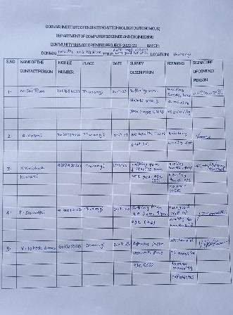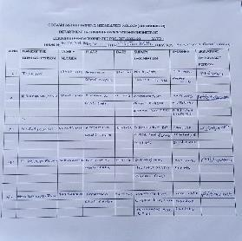

Fig:4

### The following results we saw:

Blood pressure -7

Heart problems -2 Eye vision defect-5 Diabetes -15

Obesity -4

Gastric problems-8 Thyphoid -5 Asthma-3

No health issues -5

Others (allergy, stomach pain, cold and flu, etc...)- 6

Fig:5

## RESEARCH AND RESULT:

According to our survey we concluded data based on people we met and made a research:

* Most of the people are suffering with diabetes according to our survey, about 28.57% people are suffering with diabetes.
* About 11.9% people are suffering with blood pressure according to our survey.
* About 7.14% people are suffering with thyroid
* About 7.14% people are suffering with asthma and according to our research.
* about 4.76% people are suffering with gastric troubles
* about 4.76% people are suffering with heart problems.
* about 4.76% people are suffering with obesity.
* about 4.76% people are suffering with eye vision defect.
* about 14.28% of people are suffering with other health diseases like allergy, stomach pain , cold

, cough, flu and etc.. and they take required medication.

* according to our survey 11.90% of people have no health issues and they are maintaining their health by following healthy diet and regular exercise.
* We observed contaminated water and poor sanitation are linked to transmission of diseases such as cholera, diarrhoea, dysentery, hepatitis A, typhoid and polio.
* Absent, inadequate, or inappropriately managed water and sanitation services expose individuals to preventable health risks.
* We found that having clean water and sanitation means being able to avoid exposure to countless diseases. Every year, millions of people die from diseases caused by inadequate water supply, sanitation, and impacts.
* After our research we found that other than pneumonia, diarrhea is the main cause of death in children under age.
* People with low incomes are more likely to live in polluted areas and have unsafe drinking water.
* We observed that children and pregnant women are at higher risk of health problems related to pollution.
* Environmental pollutants can cause health problems like respiratory diseases, heart disease, and some types of cancer which we want to reduce by creating awareness.
* High density living is one of the most poorly maintained areas in respect of impacts and sanitization.

32 | P a g e

* Lack of education in people is one the main reason for poorly Impacts areas because many people from poor areas drop out from schools to go to works at young age.
* We observed that village tanks are not properly cleaned and are used for bathing purposes that contaminates drinking water causing various diseases.
* In spite of this sinful misuse of village tanks, villages have not been destroyed by epidemics.
* It is the universal medical evidence that this neglect to ensure purity of the water supply of villages is responsible for many of the diseases suffered by the villagers.

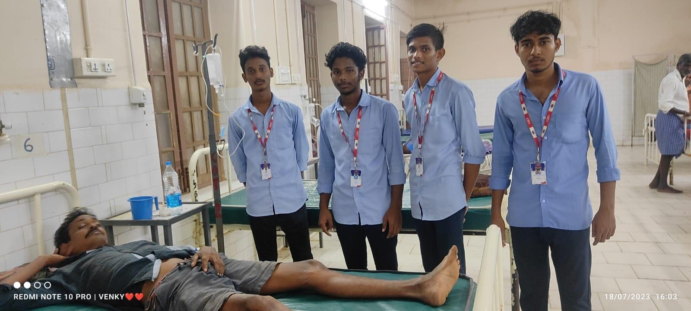

FIG:5

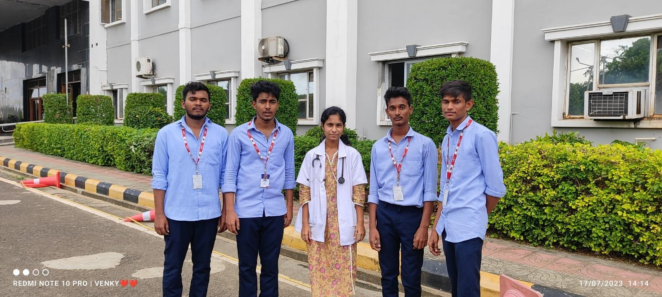

FIG:6

## PLANNING:

My team had plan to organize the minds of people in the backward areas by suggesting them some modern techniques in treating common health issues in present times. The main purpose of this is to let them know the importance of HEALTH CARE AWARENESS AND THEIR IMPACTSand make a change to live a beautiful life. Projects are designed to meet specific objectives like for us personally

* + Engage in the valuable work of helping others.
  + Practice life skills such as organizing problem-Solving and decision-making.
  + Increase com
  + munition skills.
  + Build teamwork, cooperation and diversity skills.
  + Develop self-confidence and a sense of empowerment that comes from reaching out and helping others.
  + Practice good citizenship by making a difference in the community.
  + Gain experience in the work world.
  + Share ideas and gain more knowledge.
  + Creating awareness among general public.

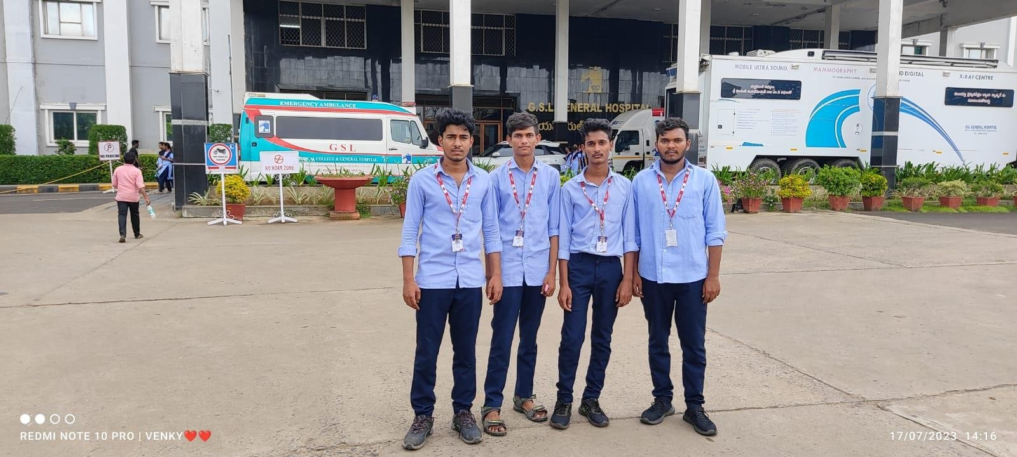

FIG:7

## ACTION PLAN AND SELF MANAGEMENT SKILLS:

We accompanied the tasks like health & impacts data and getting awareness on the recent era how peoples are suffering with health problems for not knowing proper guidelines to be Impacts in our daily life.

Most of the Persons are not aware on the disadvantages of not becoming impacts in our daily world & getting illness easily.

For understating the recent era of Health & Impacts data we took paper survey with the locality persons from different locations to know there daily personal impacts and health problems.

### Actions we took to aware people:

Making people to understand how impacts and health is important in our daily life through

* + Making understandable how surroundings is also a main factor for health issue and keeping it impacts of our surroundings.
  + Explaining Personal impacts is one of the key factor for not getting health issues and becoming good (ex: washing hands, taking care of ears, skin & proper diet) Developing healthy habits and attitudes.
  + Explaining the symptoms of some sever health issues and remedies to get rid of it for getting common basic knowledge about health issues.

In this way we visited the areas in our locality and served the people and created some awareness on the health & impacts and the uses being impacts also me and my team educated the people on the disadvantages of some health issues and remedies to it.

From all the activities we understand responsibility of health not only depend on us it depends on individual responsibility, community responsibility and state responsibility. It all connects through our surroundings and cleanness. Communicating with peoples personally face to face increases our communication skills and got a personal view of peoples how they are facing problems in today’s era.

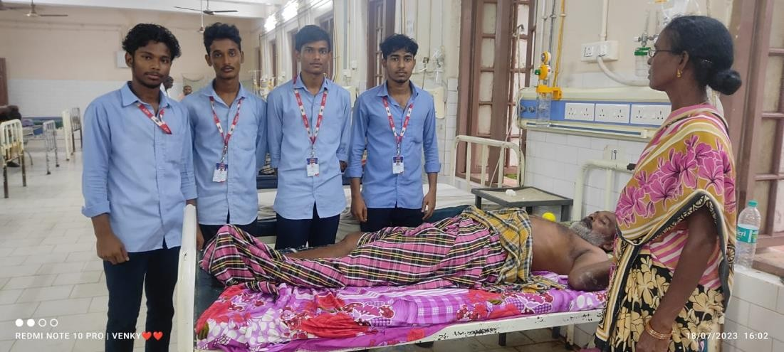

FIG:8

# CHAPTER 6: RECOMMENDATIONS AND CONCLUSIONS OF THE MINI PROJECT

## RECOMMENDATIONS:

* + - Maintain cleanliness of village and localities through proper garbage disposal.
    - Set up hospitals and dispensaries to provide medical facilities to the general public either free of cost or at highly subsidized rates.
    - Talk to the municipality about ULV spraying, to kill mosquitoes.
    - Ensure that prescribed standards are strictly followed.
    - Dispose garbage properly.
    - Make sure to clean the water gutters after the rain.
    - Turn over or remove clay pots and plastic containers.
    - Don’t use plastic unnecessarily.
    - Recycle plastic bags as many times you can.
    - Clean your house and its surroundings daily.
    - Do not tie your cattle in your house, tie them in your field

## CONCLUSION:

After the completion of this survey, we came to know that there are many people out there leading their life without knowing the basic precautions that are needed to have a proper health. We hope that the advices we gave them to the villagers are useful to them, and we think they will implement those advices in their daily life.

Although we know that there is a lot of information that is needed to be spread about **“HEALTH CARE AWARENESS AND THEIR IMPACTS”,** but one thing that we are sure of that if the information that we provided to them will help them in their daily life if they implement it.

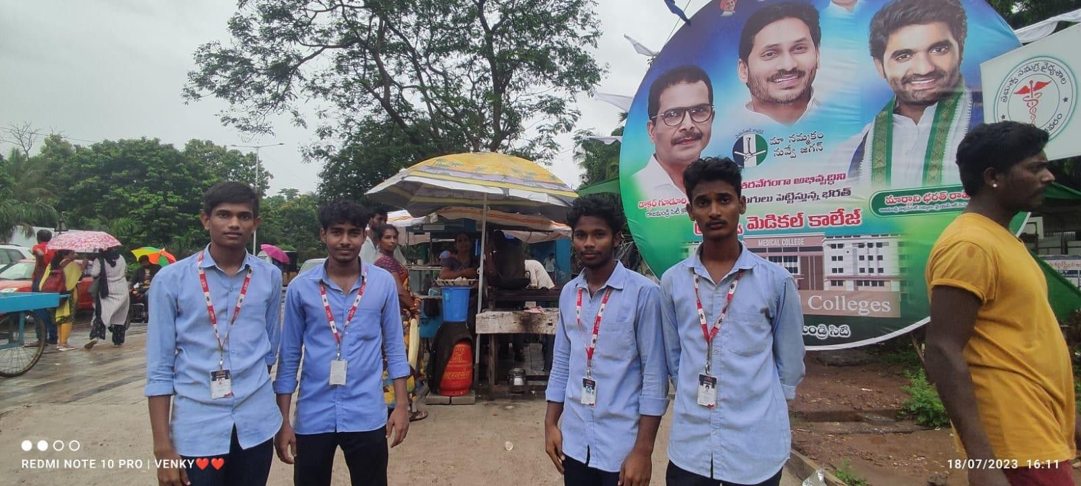`

FIG:9

#### Student Self-Evaluation for the Community Service Project

**Student Name: D,Ajay Chakri**

**Registration No: 22551A4411**

**Period of CSOP: 180Hrs : From : 18-07-2023 To : 22-08-2023**

**Date of Evaluation:**

**Please rate your performance in the following areas:**

**Rating Scale: Letter grade of CGPA calculation to be provided**

|  |  |  |  |  |  |
| --- | --- | --- | --- | --- | --- |
| 1 Oral communication | 1 | 2 | 3 | 4 | 5 |
| 2 Written communications | 1 | 2 | 3 | 4 | 5 |
| 3 Proactiveness | 1 | 2 | 3 | 4 | 5 |
| 4 Interaction ability with community | 1 | 2 | 3 | 4 | 5 |
| 5 Positive Attitude | 1 | 2 | 3 | 4 | 5 |
| 6 Self-confidence | 1 | 2 | 3 | 4 | 5 |
| 7 Ability to learn | 1 | 2 | 3 | 4 | 5 |
| 8 Work Plan and organization | 1 | 2 | 3 | 4 | 5 |
| 9 Professionalism | 1 | 2 | 3 | 4 | 5 |
| 10 Creativity | 1 | 2 | 3 | 4 | 5 |
| 11 Quality of work done | 1 | 2 | 3 | 4 | 5 |
| 12 Time Management | 1 | 2 | 3 | 4 | 5 |
| 13 Understanding the Community | 1 | 2 | 3 | 4 | 5 |
| 14 Achievement of Desired Outcomes | 1 | 2 | 3 | 4 | 5 |
| **15 OVERALL PERFORMANCE** | **1** | **2** | **3** | **4** | **5** |

**Date: Signature of the Student**

#### Student Self-Evaluation for the Community Service Project

**Student Name: D.Venkateswara Rao**

**Registration No: 22551A4412**

**Period of CSOP: 180Hrs : From : 18-07-2023 To : 22-08-2023**

**Date of Evaluation:**

**Please rate your performance in the following areas:**

**Rating Scale: Letter grade of CGPA calculation to be provided**

|  |  |  |  |  |  |
| --- | --- | --- | --- | --- | --- |
| 1 Oral communication | 1 | 2 | 3 | 4 | 5 |
| 2 Written communications | 1 | 2 | 3 | 4 | 5 |
| 3 Proactiveness | 1 | 2 | 3 | 4 | 5 |
| 4 Interaction ability with community | 1 | 2 | 3 | 4 | 5 |
| 5 Positive Attitude | 1 | 2 | 3 | 4 | 5 |
| 6 Self-confidence | 1 | 2 | 3 | 4 | 5 |
| 7 Ability to learn | 1 | 2 | 3 | 4 | 5 |
| 8 Work Plan and organization | 1 | 2 | 3 | 4 | 5 |
| 9 Professionalism | 1 | 2 | 3 | 4 | 5 |
| 10 Creativity | 1 | 2 | 3 | 4 | 5 |
| 11 Quality of work done | 1 | 2 | 3 | 4 | 5 |
| 12 Time Management | 1 | 2 | 3 | 4 | 5 |
| 13 Understanding the Community | 1 | 2 | 3 | 4 | 5 |
| 14 Achievement of Desired Outcomes | 1 | 2 | 3 | 4 | 5 |
| **15 OVERALL PERFORMANCE** | **1** | **2** | **3** | **4** | **5** |

**Date: Signature of the Student**

#### Student Self-Evaluation for the Community Service Project

**Student Name: P.Mani Kanta**

**Registration No: 22551A4440**

**Period of CSOP: 180Hrs : From : 18-07-2023 To : 22-08-2023**

**Date of Evaluation:**

**Please rate your performance in the following areas:**

**Rating Scale: Letter grade of CGPA calculation to be provided**

|  |  |  |  |  |  |
| --- | --- | --- | --- | --- | --- |
| 1 Oral communication | 1 | 2 | 3 | 4 | 5 |
| 2 Written communications | 1 | 2 | 3 | 4 | 5 |
| 3 Proactiveness | 1 | 2 | 3 | 4 | 5 |
| 4 Interaction ability with community | 1 | 2 | 3 | 4 | 5 |
| 5 Positive Attitude | 1 | 2 | 3 | 4 | 5 |
| 6 Self-confidence | 1 | 2 | 3 | 4 | 5 |
| 7 Ability to learn | 1 | 2 | 3 | 4 | 5 |
| 8 Work Plan and organization | 1 | 2 | 3 | 4 | 5 |
| 9 Professionalism | 1 | 2 | 3 | 4 | 5 |
| 10 Creativity | 1 | 2 | 3 | 4 | 5 |
| 11 Quality of work done | 1 | 2 | 3 | 4 | 5 |
| 12 Time Management | 1 | 2 | 3 | 4 | 5 |
| 13 Understanding the Community | 1 | 2 | 3 | 4 | 5 |
| 14 Achievement of Desired Outcomes | 1 | 2 | 3 | 4 | 5 |
| **15 OVERALL PERFORMANCE** | **1** | **2** | **3** | **4** | **5** |

**Date: Signature of the Student**

#### Student Self-Evaluation for the Community Service Project

**Student Name: V.H.M.Ganesh**

**Registration No: 22551A4454**

**Period of CSOP: 180Hrs : From : 18-07-2023 To : 22-08-2023**

**Date of Evaluation:**

**Please rate your performance in the following areas:**

**Rating Scale: Letter grade of CGPA calculation to be provided**

|  |  |  |  |  |  |
| --- | --- | --- | --- | --- | --- |
| 1 Oral communication | 1 | 2 | 3 | 4 | 5 |
| 2 Written communications | 1 | 2 | 3 | 4 | 5 |
| 3 Proactiveness | 1 | 2 | 3 | 4 | 5 |
| 4 Interaction ability with community | 1 | 2 | 3 | 4 | 5 |
| 5 Positive Attitude | 1 | 2 | 3 | 4 | 5 |
| 6 Self-confidence | 1 | 2 | 3 | 4 | 5 |
| 7 Ability to learn | 1 | 2 | 3 | 4 | 5 |
| 8 Work Plan and organization | 1 | 2 | 3 | 4 | 5 |
| 9 Professionalism | 1 | 2 | 3 | 4 | 5 |
| 10 Creativity | 1 | 2 | 3 | 4 | 5 |
| 11 Quality of work done | 1 | 2 | 3 | 4 | 5 |
| 12 Time Management | 1 | 2 | 3 | 4 | 5 |
| 13 Understanding the Community | 1 | 2 | 3 | 4 | 5 |
| 14 Achievement of Desired Outcomes | 1 | 2 | 3 | 4 | 5 |
| **15 OVERALL PERFORMANCE** | **1** | **2** | **3** | **4** | **5** |

**Date: Signature of the Student**

#### Evaluation by the Person in-charge in the Community / Habitation

**Student Name: D.Ajay Chakri**

**Registration No: 22551A4411**

**Period of CSOP: 180Hrs : From : 18-07-2023 To : 22-08-2023**

**Date of Evaluation:**

**Name of the Person in-charge:**

**Address with mobile number:**

Please rate the student’s performance in the following areas:

Please note that your evaluation shall be done independent of the student’s

self-valuation

Rating Scale: 1 is lowest and 5 is highest rank

|  |  |  |  |  |  |
| --- | --- | --- | --- | --- | --- |
| 1 Oral communication | 1 | 2 | 3 | 4 | 5 |
| 2 Written communications | 1 | 2 | 3 | 4 | 5 |
| 3 Proactiveness | 1 | 2 | 3 | 4 | 5 |
| 4 Interaction ability with community | 1 | 2 | 3 | 4 | 5 |
| 5 Positive Attitude | 1 | 2 | 3 | 4 | 5 |
| 6 Self-confidence | 1 | 2 | 3 | 4 | 5 |
| 7 Ability to learn | 1 | 2 | 3 | 4 | 5 |
| 8 Work Plan and organization | 1 | 2 | 3 | 4 | 5 |
| 9 Professionalism | 1 | 2 | 3 | 4 | 5 |
| 10 Creativity | 1 | 2 | 3 | 4 | 5 |
| 11 Quality of work done | 1 | 2 | 3 | 4 | 5 |
| 12 Time Management | 1 | 2 | 3 | 4 | 5 |
| 13 Understanding the Community | 1 | 2 | 3 | 4 | 5 |
| 14 Achievement of Desired Outcomes | 1 | 2 | 3 | 4 | 5 |
| **15 OVERALL PERFORMANCE** | **1** | **2** | **3** | **4** | **5** |

**Date: Signature of the Supervisor**

#### Evaluation by the Person in-charge in the Community / Habitation

**Student Name: D.Venkateswara Rao**

**Registration No: 22551A4412**

**Period of CSOP: 180Hrs : From : 18-07-2023 To : 22-08-2023**

**Date of Evaluation:**

**Name of the Person in-charge:**

**Address with mobile number:**

Please rate the student’s performance in the following areas:

Please note that your evaluation shall be done independent of the student’s

self-valuation

Rating Scale: 1 is lowest and 5 is highest rank

|  |  |  |  |  |  |
| --- | --- | --- | --- | --- | --- |
| 1 Oral communication | 1 | 2 | 3 | 4 | 5 |
| 2 Written communications | 1 | 2 | 3 | 4 | 5 |
| 3 Proactiveness | 1 | 2 | 3 | 4 | 5 |
| 4 Interaction ability with community | 1 | 2 | 3 | 4 | 5 |
| 5 Positive Attitude | 1 | 2 | 3 | 4 | 5 |
| 6 Self-confidence | 1 | 2 | 3 | 4 | 5 |
| 7 Ability to learn | 1 | 2 | 3 | 4 | 5 |
| 8 Work Plan and organization | 1 | 2 | 3 | 4 | 5 |
| 9 Professionalism | 1 | 2 | 3 | 4 | 5 |
| 10 Creativity | 1 | 2 | 3 | 4 | 5 |
| 11 Quality of work done | 1 | 2 | 3 | 4 | 5 |
| 12 Time Management | 1 | 2 | 3 | 4 | 5 |
| 13 Understanding the Community | 1 | 2 | 3 | 4 | 5 |
| 14 Achievement of Desired Outcomes | 1 | 2 | 3 | 4 | 5 |
| **15 OVERALL PERFORMANCE** | **1** | **2** | **3** | **4** | **5** |

**Date: Signature of the Supervisor**

#### Evaluation by the Person in-charge in the Community / Habitation

**Student Name: P.Mani Kanta**

**Registration No: 22551A4440**

**Period of CSOP: 180Hrs : From : 18-07-2023 To : 22-08-2023**

**Date of Evaluation:**

**Name of the Person in-charge:**

**Address with mobile number:**

Please rate the student’s performance in the following areas:

Please note that your evaluation shall be done independent of the student’s

self-valuation

Rating Scale: 1 is lowest and 5 is highest rank

|  |  |  |  |  |  |
| --- | --- | --- | --- | --- | --- |
| 1 Oral communication | 1 | 2 | 3 | 4 | 5 |
| 2 Written communications | 1 | 2 | 3 | 4 | 5 |
| 3 Proactiveness | 1 | 2 | 3 | 4 | 5 |
| 4 Interaction ability with community | 1 | 2 | 3 | 4 | 5 |
| 5 Positive Attitude | 1 | 2 | 3 | 4 | 5 |
| 6 Self-confidence | 1 | 2 | 3 | 4 | 5 |
| 7 Ability to learn | 1 | 2 | 3 | 4 | 5 |
| 8 Work Plan and organization | 1 | 2 | 3 | 4 | 5 |
| 9 Professionalism | 1 | 2 | 3 | 4 | 5 |
| 10 Creativity | 1 | 2 | 3 | 4 | 5 |
| 11 Quality of work done | 1 | 2 | 3 | 4 | 5 |
| 12 Time Management | 1 | 2 | 3 | 4 | 5 |
| 13 Understanding the Community | 1 | 2 | 3 | 4 | 5 |
| 14 Achievement of Desired Outcomes | 1 | 2 | 3 | 4 | 5 |
| **15 OVERALL PERFORMANCE** | **1** | **2** | **3** | **4** | **5** |

**Date: Signature of the Supervisor**

#### Evaluation by the Person in-charge in the Community / Habitation

**Student Name: V.H.M.Ganesh**

**Registration No: 22551A4454**

**Period of CSOP: 180Hrs : From : 18-07-2023 To : 22-08-2023**

**Date of Evaluation:**

**Name of the Person in-charge:**

**Address with mobile number:**

Please rate the student’s performance in the following areas:

Please note that your evaluation shall be done independent of the student’s

self-valuation

Rating Scale: 1 is lowest and 5 is highest rank

|  |  |  |  |  |  |
| --- | --- | --- | --- | --- | --- |
| 1 Oral communication | 1 | 2 | 3 | 4 | 5 |
| 2 Written communications | 1 | 2 | 3 | 4 | 5 |
| 3 Proactiveness | 1 | 2 | 3 | 4 | 5 |
| 4 Interaction ability with community | 1 | 2 | 3 | 4 | 5 |
| 5 Positive Attitude | 1 | 2 | 3 | 4 | 5 |
| 6 Self-confidence | 1 | 2 | 3 | 4 | 5 |
| 7 Ability to learn | 1 | 2 | 3 | 4 | 5 |
| 8 Work Plan and organization | 1 | 2 | 3 | 4 | 5 |
| 9 Professionalism | 1 | 2 | 3 | 4 | 5 |
| 10 Creativity | 1 | 2 | 3 | 4 | 5 |
| 11 Quality of work done | 1 | 2 | 3 | 4 | 5 |
| 12 Time Management | 1 | 2 | 3 | 4 | 5 |
| 13 Understanding the Community | 1 | 2 | 3 | 4 | 5 |
| 14 Achievement of Desired Outcomes | 1 | 2 | 3 | 4 | 5 |
| **15 OVERALL PERFORMANCE** | **1** | **2** | **3** | **4** | **5** |

**Date: Signature of the Supervisor**

PHOTOS

Fig:6

Fig:7

37 | Page

+

Fig:8

Fig:9

38| P a g e

Fig:10

Fig:11

39 | P a g e

